
The Brickfield Accessibility Toolkit is a platform that helps improve the accessibility of Moodle course content for all students. It provides an automated evaluation of course content and assessments for accessibility issues, and bulk updates unclear or missing text for web links, image descriptions, and video subtitles. This toolkit provides accessible and alternative file formats for students and identifies which activities have the most accessibility issues, that enables lecturers to fix common mistakes and future-proof their course content.

What alternate formats are there?

Text formats
The File Convertor can change the format of file PDF, Word Documents, PowerPoint type resources into alternate text-based formats such as Word – Doc, or DOCX, RTF (Rich Text Format), Tagged PDF, HTML, Plain text and others depending on the source file.
Depending on the document type of the source document, a number of conversion options are available for automated document remediation.

MP3 Audio Files
Audio files in MP3 are great for people who want to read whilst on the move. MP3 files can also be used as an accommodation for people with blindness, low vision, or dyslexia. Furthermore, MP3 files can be used by mainstream users such as flexible learners and foreign-language learners to support learning. MP3 is a format that is well-known to users and most users will have some kind of device that is capable of playing back MP audio files, e.g., their smartphone.

E-Books
E-books are reflow-able and allow users to change everything about their visual appearance. E-books can be scaled up without breaking the margins, fonts can be substituted, the background and foreground colour combination can be changed, as can the contrast, lines spacing, and scrolling direction to match the individual needs and preferences of the user.
The File Convertor can convert documents into a number of different formats: EPUB is a standardised format supported by most e-book readers. Mobi Pocket is an e-book format supported by Amazon. EPUB3 is the latest version of EPUB and supports sophisticated content such as mathematical equations.

DAISY Structured Audio Books
DAISY books are structured audio books. Using a DAISY reader, the text is highlighted as the user reads. In addition, the user can navigate the document using the heading structure, pages and page numbers. Users can also insert bookmarks and change the visual appearance of the book.
The File Convertor can convert accessible documents into structured audio books in the DAISY format. Source documents must be submitted as Word documents and must comply with the formal accessibility requirements.

Braille
The File Convertor can transcribe documents into Braille according to a number of (national) Braille systems and contraction levels. Furthermore, SensusAccess can format and paginate Braille, and deliver the resulting files as either portable Braille or Braille encoded for a particular Braille device or Braille character set.
Transcribed documents can subsequently be embossed on a Braille embosser, displayed on a Braille display connected to a computer or smartphone, or loaded on to a Braille notetaker.

What is File Document Conversion?
You can convert the PDFs, slides, scanned articles, Book resources and lecture notes into alternate formats that work best for you such as
- MP3 files
- E-books
- Digital Braille books
- Structured audio books in DAISY and e-books with media overlay
Once you have logged into Moodle and entered your course, you will see a new icon at the end of the file resources name as in the below screenshot:
How do I use the file conversion tool?
- Log into Moodle and enter your course
- Find the required file on your Moodle course
- Select the file conversion icon
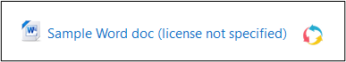
- Choose your new file format
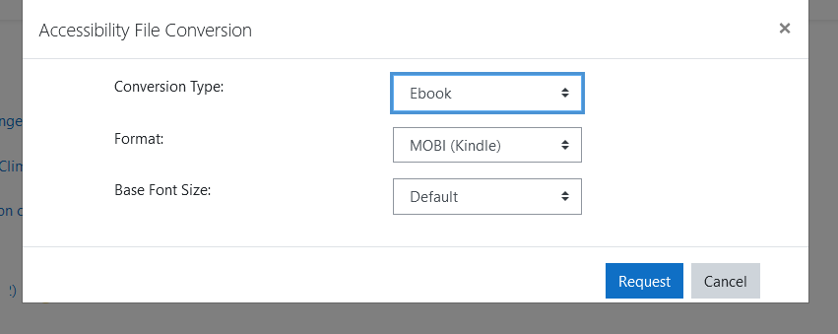
Select how you would like your file to be converted by choosing Type and other appropriate settings and select Request.
- If your file has already been converted to your requested format, the file will download immediately.
- If this was the first time it was requested, conversion is queued, and you will be told content retrieval in progress. You will be notified when the file is available in Moodle or via email to your student account.
Note:
Depending on the size of the file resource it may take a couple of minutes to generate or longer in some cases. A notification will appear onscreen when the process is complete.
Different conversion types
The Conversion types that are available when requesting a file conversion are dependent on the file type, so in this example case for a Word document, the conversion types with their respective settings are as follows:
- Conversion type: Text
  - Format: PDF - Tagged PDF, txt - Plain text
- Conversion type: Audio
  - Document language
  - Audio Speed
- Conversion type: Ebook
  - Format: MOBI (Kindle), EPUB, EPUB3 with media overlay
  - Base Font Size
- Conversion type: Daisy
  - Format: Talking book
- Conversion type: Braille
  - Output Format: Pef, NACB, Unicode, UTF8
  - Contraction: Grade 1, Grade 2
  - Page numbering: None, right, left
  - Duplex (Pef only): No, Yes
Each different conversion type has a different range of formats on offer. For instance, if the user selects the Audio type, they then can select the language that the original document has been composed in, and the speed that they want the audio to be converted to, as different usages of audio benefit from different ranges of speed.

