

Visitor parking booking form

Visitor parking requested by:

Visitor dates | Arriving time | Departing time | No. of visitors | Visitor Name | Car reg | Email Mandatory to receive QR Code

Visitors will receive an email with an attachment containing a QR code. Visitors must then scan this QR code at the barrier for entry.
Please Email completed form to: midwest_estates@tus.ie

Visitor car park location on google maps: https://maps.app.goo.gl/NqLYkFzbwuWYGmjd6
Follow the red arrows to the Visitor’s car park marked no. 3 below:
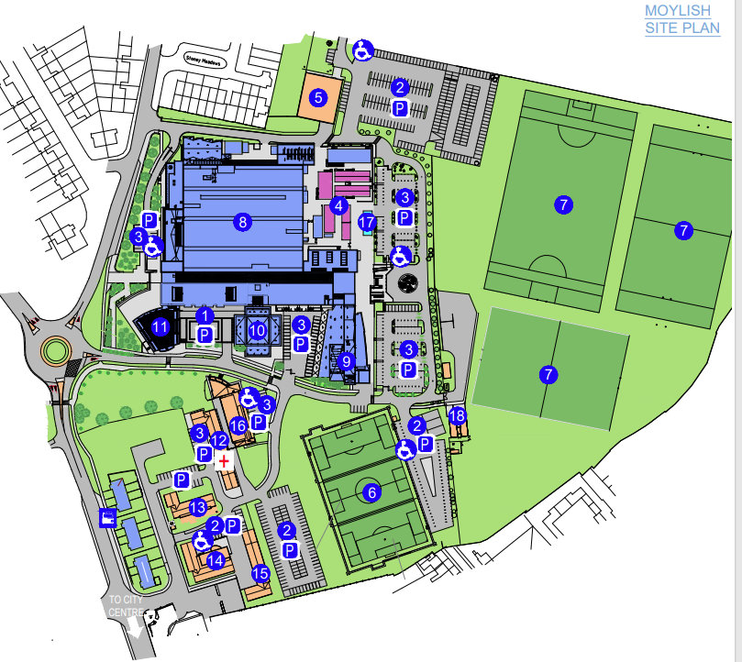

19 spaces

